**Prototype Development Document**

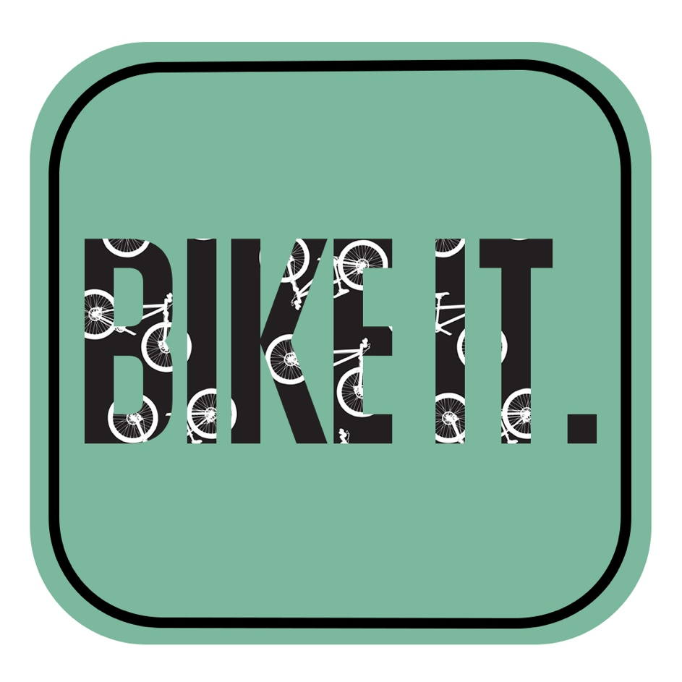

**Team Name:** Bike IT / Team 5

**Team Members:** Adam Downing, Amy Lai, James Throp, Joe Daly, Tabie Ledesma, Zunaira Arshad

**Contents**

1. **Introduction**
2. **Rationale for the choice of Prototype**
3. **Link to User Requirements**
4. **Design Decisions Undertaken**
5. **Reflection on the Process of Project**
6. **Conclusion**
7. **References**
8. **Introduction**

This document is an accumulation of our teams thought process when developing the prototype. It will explain how we have achieved our finished prototype and what steps we have taken. Additionally, it will go into detail about the rationale for this prototype, why we have decided to print it off rather than use digital copies, also how we came to agree on the arrangement of the print out prototypes and why we have chosen the specific screens to print out. Then the document explains the design behind our prototype, such as the reasons for the chosen layout, the logic behind the logo, why the font has been chosen and how the buttons work.

Moreover, it gives depth as to whether we have met the user’s requirements and the conclusions that we have been able to draw from this project, describing the next steps we could take if we were proceeding with the project. From this document we are able to see the progression of the prototype and can summarise how we have come to our final product, giving further detail on what we have achieved and what we haven’t. Additionally, whilst reflecting on the process of the project we are able to express if the initial scope plan had changed from the beginning and if so, what has changed.

1. **Rationale for the choice of the Prototype**

A prototype is an “interactive sketch of the product/service” that is being built (Soderlund, 2015). For our prototype of choice, as a team we decided a printed prototype would best suit our application idea. We strongly felt that a printed version would be the most appropriate for our app idea as it will be the easiest way for potential clients to understand and navigate their way through the app.

Although we were given other ways to present our prototype, the other options were not as straight forward and reliable enough to be able to present our idea accordingly. For example, we had the option to produce a digital prototype. However, we felt that this would be unnecessary and over complicate the idea of the app.

For our printed prototype, it will be presented on a size A3 paper in colour and this is an important choice as the colour and design reflect the idea of the brand essence. The green colour represents nature and the environment (Bourne Creative, 2018) which shows that our brand/idea is ethical. And this is because travelling by cycling is a very environmentally friendly way to travel.

Therefore, having a physical prototype was most suited as you will actually get to see the green colour scheme and what the app will look like if it ever was made. By creating different pages for the app, we are able to see the process of logging in/ signing up to the directions a cyclist can take on their desired journey.

As this was an initial idea at the beginning stages, it allowed us to quickly see the prototype and see how it would turn out if it were actually to be made. And to see if we needed any changes or additions to the initial idea. Therefore, we haven’t wasted our time in creating and coding an app, to find out that did not work and therefore, can be easily modified. A trial and error situation were done in the most efficient way for us as a team.

Another reason why we chose a printed prototype was so that the team isn’t constrained by an existing app because this is an initial and prototype idea, going with the first idea and creating it would cause a lot of unrequired stress. By doing a printed prototype, we are able to receive feedback on the prototype, therefore, we are able to modify and change easily and quickly and no large costs. Being able to find errors early on in the process, puts the team at an advantage because it will cause less stress and wasted time, saving our energy for when the prototype because an actual product (Nomensa, 2018).

1. **Link to User Requirements**

Safe and secure parking is one of the key elements of the app, BikeIT allows you to lock your bike up securely and safely. Users will have peace of mind when using our app as they will be able to track their bike on their phone and will be altered if any tries to take their bike. In 2015 in the city of Manchester over 1700 bikes were reported stolen (*Manchester Evening News*, 2016). This shows that bike theft is a big problem in Manchester and with an app like ours, people would be able to know they have somewhere safe to lock their bikes up.

For BikeIT, the map and track aspect of the app is one of the most important parts as this is where users will be able to keep track of their bike and keep track of how many different bike locks are free and the location of these free bike locks. The interface is designed so that everything is clear and simple this is to make it as quick and easy as possible as people will usually be on their way to university or work, so they will need a quick and simple app that doesn’t take too long to access the features they need.

The BikeIT app will clearly display when locks are free and have not been reserved online this means when you find a lock that has not been reserved online it will be free to use these locks will be marked clearly on the app, so users can quickly identify whether a lock is free to use or has already been reserved online.

Another user requirement for the BikeIT app is the feature of having the distance to the users desired parking location. A user would require this feature as they can determine whether a particular parking lock is suitable for their certain needs. By having clear information about how far and where these bike locks are it could reduce the common problem of bike theft. Mobike’s are a bike sharing firm operating in Manchester had the problem of not having any dedicated bike locks.

As explained by BBC News, ‘Mobike to pull out of Manchester after losing 10% of its cycles each month to theft and vandalism’ (*BBC News*, 2018). Furthermore, login and registration pages are essential for users when using this app. By having a login feature for BikeIT, information can be safely stored in the app and therefore provides a sense of security for the users. Privacy and security should be the priority of any app and by having registered accounts it keeps people's information safe. Furthermore, by having a unique registered account, the app can be personalised to the user’s particular needs. For example, when the user inputs all their details, the app can use this information to find out what bike locks in Manchester they might want to use.

1. **Design Decisions Undertaken**

For our BikeIT app we decided to be very specific and minimal when it comes down to deciding the design. Certain colours, layouts and fonts were chosen which all take part towards how users can easily navigate their way throughout the app.

**Phone Setting Design:**

For the team’s design prototype, we decided we wanted it to be presented as an iPhone format including an iPhone template surrounding the page. We felt that this sleek and minimal design will look professional and well-presented rather than just developing it as an app page on its own.

Here are 2 examples out of the 5 completed prototype print:

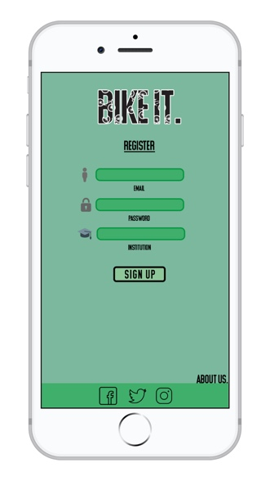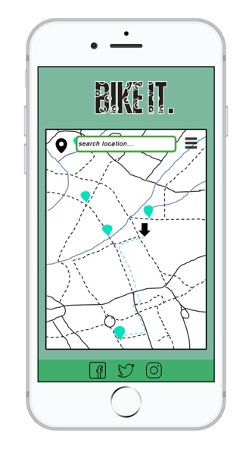

This design output would visualise to the user how it would look like on an iPhone. We felt that this would be an easy interface for users to work with due to the fact that the majority of society are more dependent on their devices more than ever. Therefore, it would only be appropriate to design it in a phone application format.

Furthermore, if the prototype was to go forward into the next stages of actually creating the app, the group would have a clear idea of how the app would appear on a device.

We wanted to make sure that the layout of the app was consistent on each page for users to easily navigate. As a group, we decided to avoid over complicated layouts that could confuse the user and wanted to make the app as clear as possible. As well as this, the app itself looks youthful and student friendly.

**Content:**

The map page was constructed and inspired by other existing transport apps. We went for simple theme as we didn’t want to complicate the map and make it easy to use. The top search bar allows quick and easy search, and the menu icon allows the user to go back onto other pages such as the profile page or log in page. The register page has the about us link button, which allows the user to find out information about us and the app itself before deciding to register for the app.

For the about page, we gathered information from our user requirements in order to form a quick insight on what the app is about. We made sure to cover the key elements (ie. Paid reserved spaces, quicker routes, etc) that feature within the app. As well as this, we have decided to include a reviews section to give the user an insight on previous and/or current users opinions of the app.

**Design Sketches:**

Developing a prototype ranges from “rough paper sketches to interactive stimulations that look and function like the final product” (*Smashing Magazine,* 2010). In the process of deciding the design of the app, it is vital that as a group, we must brainstorm different design ideas to see what would work within the app and what feature would be classed as irrelevant.

Here is an example of one of the pages that we drew up in process of deciding our design for the login page:

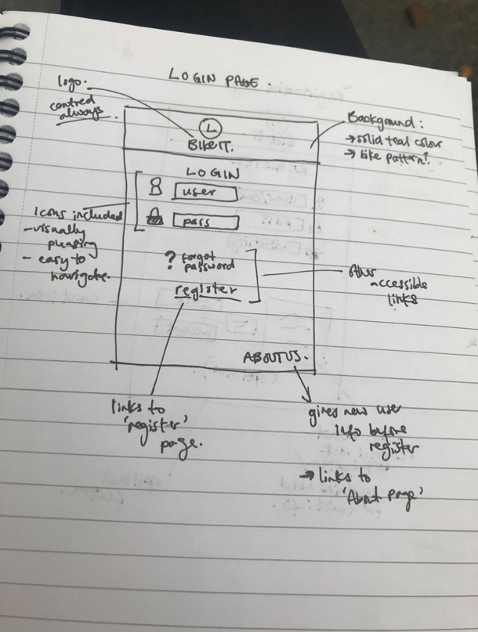

Within the sketches are also annotations included which describes what sort of function certain features or buttons would serve if they were to be included. Adding annotations or notes to the sketches during the deciding process is important as it allows the team to understand how the app would run if it were to be created. It will also give the team of developers a wider idea of what would fit well within that page and how the user can easily navigate through it.

By creating these sketches of the visualised prototype allows “rapid and iteratively” generates early feedback which contributes to improving the “final design and reducing the need for changes during development” (*Smashing Magazine,*2010). This approach of “rapid prototyping” has allowed our team to experiment with multiple ideas through the communication of visuals rather than strictly words (*Smashing Magazine,*2010).

**Colour Scheme:**



#**7bb89d**

For our colour scheme, we decided to use a set of green tones throughout the app so that each page would match the theme accordingly. We specifically chose green toned colours as it best suited our brand image. Due to the fact that BikeIT supports cyclists to navigate their way through the city centre and find the closest bike-parking, cycling itself is the most environmentally friendly way of transport.

The colour green is related to “much of our natural environment” (Skau, 2014). The colour is associated with many positive connotations such as sustainability, energy and health (Skau, 2014). The colour itself is already seen in everyone’s everyday life, therefore, seeing this colour within the app will not be something that could possibly give users a ‘sore-eye’. If anything, the colour has a “warming and cooling effect” (*Fine Art Tips,* n.d).

**Icons:**

Throughout our prototype pages, we decided that it would be a good idea to include reoccurring icons to symbolise the function of the feature. Not only would it be easier to understand, but we also wanted to keep in mind the fact that the app is targeted for students, resulting to the development team wanting the app to be easy and fun.

Here are the icons used throughout our prototype and what they represent:

|  |  |
| --- | --- |
|  | Username / Name / Login |
|  | Password |
|  | Menu |
|  | Protected Card Details |
|  | University |
|  | Social Media Links |
|  | Location |
|  | Telephone Number |
|  | Settings |

1. **Reflection on the progress of project**

In the project process we have achieved our finished prototype and I will explain the steps we have taken as a team. At the very start of the project we used post-it notes to generate the ideas of inventing something new, something that we see is missing around us. To narrow the idea into small circle digging deep into who we are, what our needs are and people who are like us that have needs they wish to be fulfilled in their daily life. Producing an idea of a bike app that navigates directions and provides available spaces is an ideal app because most students travel to university by walking. Further research lead us to come to a conclusion of students not being able to afford bikes as they are expensive, but also the increase of bike theft (Stolen Bikes, 2018) in the UK has also lead students hesitant to buy bikes. This lead to ‘25% of people giving up cycling’ and’ 66% have cycled less’ (Stolen Bikes, 2018)

To increase confidence in students of Manchester for biking, the bike idea needed advanced advertising. To achieve an effective project our next step was choosing an advertising platform, a suitable platform to promote free bike parking idea was an online app system. According to our intended audience the advertising online fits appropriately as most of the young people are exposed to online advertising, rather than physical advertisements i.e. leaflets and newspapers.

From the initial scope plan a slight change was made. The change is to benefit our app to keep the progress growing, as the project aims to be free bike parking place, we have made a small charging amount (only £1) for the reserved parking. The payment will be made online and this is for the people who plan to park a bike for long periods of time or are in a rush and need a space.

According to the team project schedule in the process we have made achievements by writing content for the app, gathered information and statistics, created media content such as a map and the logo design has been confirmed and stated by the team manager. It’s important to follow certain steps in the development of a project such as Initiation/planning, execution, control and test. The steps are followed up in this project one by one. To create a project app the first step was planning the structure and defining the objectives and goals to make sure we meet client’s requirements and expectations. The next processed step was drawing the sketches and developing the sketches into mock ups by using photoshop.

1. **Conclusion**

In conclusion, there are various ways in which we could improve the project next time. One of which is being careful with what is promised within the scope statement, we stated that we can provide safe and secure bicycle parking, but there is no actual guarantee of this as we would be unable to offer 24/7 security and over watch of the bicycles. We also found that the Gantt chart tasks were in an opposite order to the work breakdown table, it would be more useful to have it ordered in the same way as it would be easier for us to use. Furthermore, adding graph lines to the Gantt chart would have further helped by providing visual clarity. To improve our work in the future, the work breakdown list could have had additional detail by labelling how long the tasks would take, for example 2 days, 2 hours, 2 weeks.

If we were going to proceed with the project, the next-steps would be that we could take would be to carry out extensive research to see how successful the app would be in actual production. Furthermore, the design of the app would need to be finalised as tweaks may be made after the prototype has been produced. Then the development of the final product would begin, so the foundations of the app would need to be created first like buttons, navigation and database, these would be coded by developers. Once the fundamentals of the app have been created the design and layout would be implemented.

1. **References**

BBC News (2018 [Online] https://www.bbc.co.uk/news/uk-england-manchester [Accessed: 2nd December 2018]

Bourne Creative (2018). *Color Meaning: Green* [Online] [Assessed on 10th December 2018]

<https://www.bourncreative.com/meaning-of-the-color-green/> [Assessed on 10th December 2018]

Fine Art Tips (n.d) *The Color ‘Green’: How to use its Hidden Meaning for Art & Design* [online] <https://www.finearttips.com/2010/08/the-color-green-how-to-use-its-hidden-meaning-for-art-design/> [Accessed: 9th December]

M.E.N (2016) *Why are you most likely to have your bike stolen?* [Online] <https://www.manchestereveningnews.co.uk/news/greater-manchester-news/you-most-likely-your-bike-11155549> [6th December 2018]

Nomensa (2018). *UX Design* [Online]

<https://www.nomensa.com/blog/2015/ux-design-5-reasons-use-paper-prototypes> [Accessed on 10th December 2018]

Skau, D (2014). *The Power of Green in Design and Visual Content Marketing* [online] <https://visual.ly/blog/green-design-visual-content-marketing/> [Accessed: 9th December 2018]

Smashing Magazine (2010) *Design Better and Faster with Rapid Prototyping* [online] <https://www.smashingmagazine.com/2010/06/design-better-faster-with-rapid-prototyping/> [Accessed: 10th December 2018]

Stolen Bikes (2016). *Stolen Bike Study* [online] <https://stolen-bikes.co.uk/statistics/> [Accessed: December 6th 2018]

Symetris (2004 - 2018*). Symetris Digital Partners* [online]

<https://www.symetris.ca/blog/5-essential-steps-good-project-management/>

[Accessed: December 6th 2018]